Getting Started with Zoom

Welcome to Zoom! This document is designed to get you up to speed and in your very first Zoom meeting as fast as possible.

To create an account, go to https://bcm.zoom.us and click Sign In in the upper right-hand corner of the page.

Log in with your BCM Username and Password.

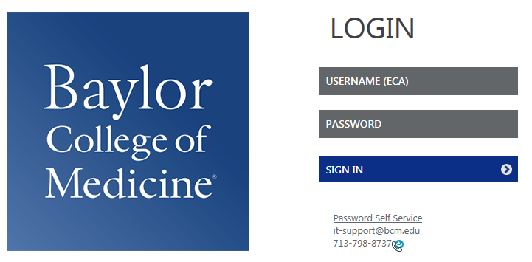

After successfully being signed in, you will be taken to your “My Profile” page.

On this page you can:

- Change your avatar (used when you turn off your camera and for our IM feature).
- Edit your Personal Meeting ID/Personal Vanity URL
- Change your Time Zone
- Change your Default Call in Country
- Change your password
- Change your Host Key (used for Personal Audio Conference)

After configuring your profile, click on My Settings to set your In Meeting, Email Notification, Security, and Scheduling Privileges preferences.

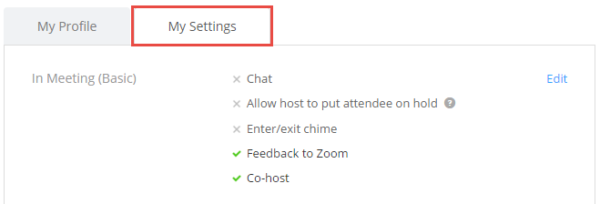

Now we need to get the actual Zoom software installed on your PC/Mac. The easiest way to do this is to head to https://zoom.us/meeting and click Start to the far right of your Personal Meeting Room.

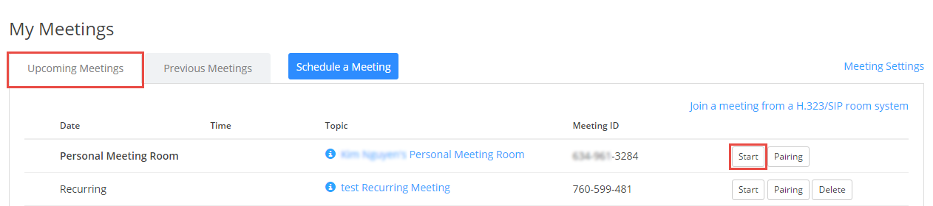

Once you click the Start button, your browser will begin the installation of the Zoom client and you will join your own Personal Meeting Room. Once successfully installed and the Meeting is started, you should be looking at yourself via your webcam. Feel free to click on End Meeting at the lower right-hand side of the Zoom interface.

You now have the Zoom client for Meetings installed. Best practice on Windows, go to the Zoom client and click on Settings at the top right. Click on General and then check the box that says “Start Zoom when I start Windows”.
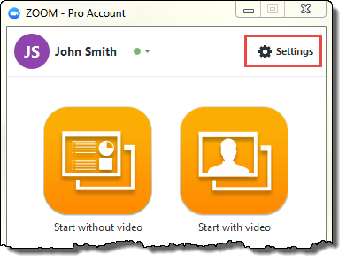

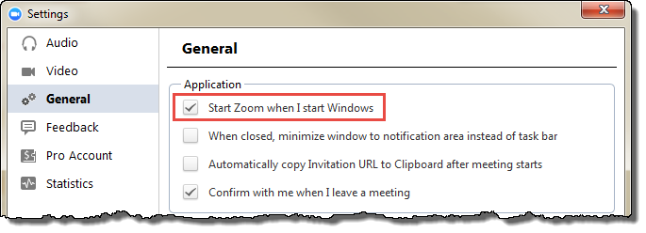

On Mac, right-click the Zoom app in the Dock, select Options > Open at Login.

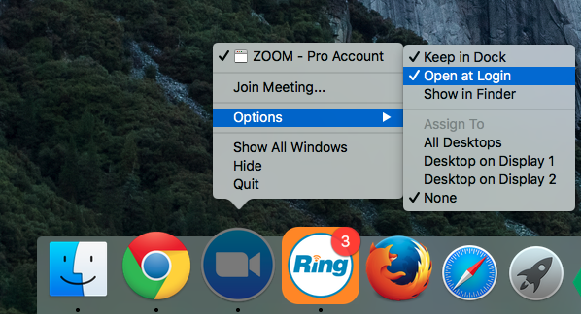

For iOS and Android devices, please visit the App Store or Google Play to install the Zoom mobile apps.

Here are some great resources from our Knowledge Base to take a deeper dive into using Zoom.

- Download the Getting Started with PC and Mac Guide
- Watch the Getting Started Videos
- Join our Weekly Zoom Meetings and Webinar training

If you require technical assistance, please contact the OIT Help Desk at (713) 798-8737 or it-support@bcm.edu.

