Step 1: Open IPEDS webpage.

❶
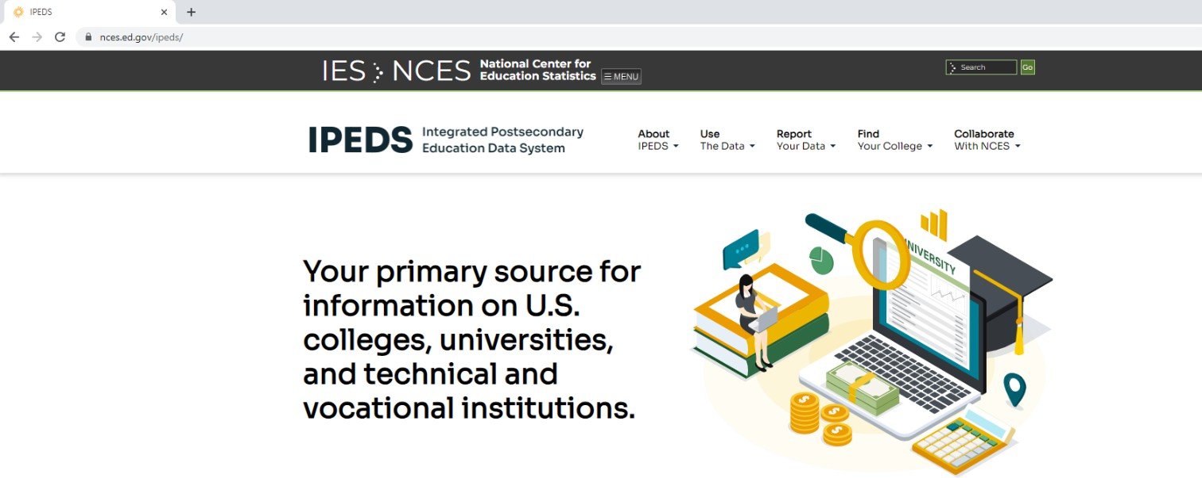

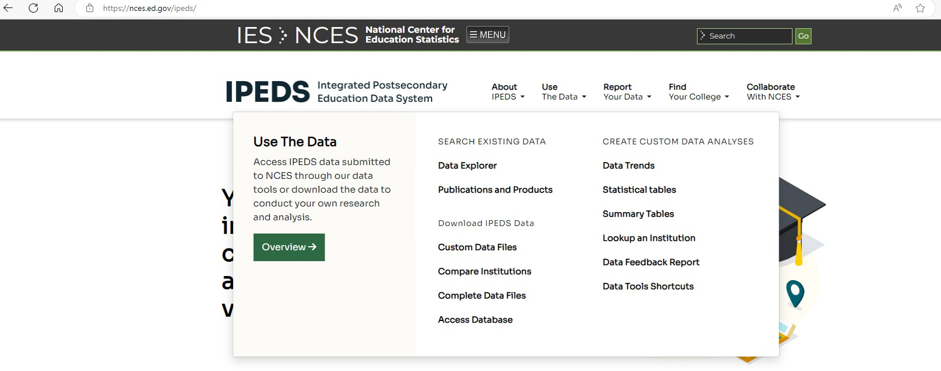
Step 2-3: Click Use The Data, and then Data Feedback Report.
❷
❸

Step 4: Type Baylor College of Medicine in the search box, and click the Search buton.
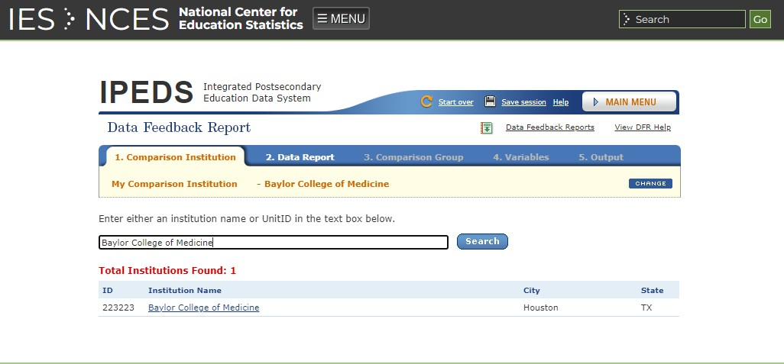
❹

Step 5: Click on Create a Custom Data Feedback Report.
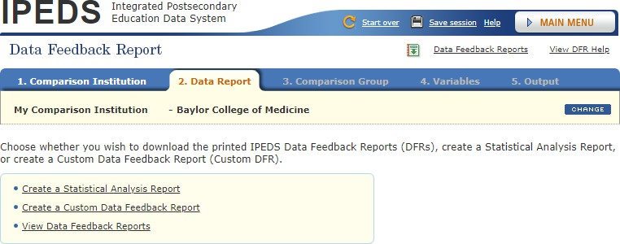
❺
For Step 6-10, there are two senarios for genera�ng peer ins�tu�ons:

- Scenario 1 – if you have a speciﬁc ins�tu�on or a group of ins�tu�ons for
comparison.
- Scenario 2 – if you don’t have a speciﬁc ins�tu�on in mind.

Scenario 1 – If you have a speciﬁc ins�tu�on or a group of ins�tu�ons for comparison
Step 6: Under By Names and UnitIDs, enter a ins�tu�on name or UnitID for a one-on-one comparison, or a comma separated list of UnitIDs for a group comparion, into the Ins�tu�on Name box, and then click the Select buton.
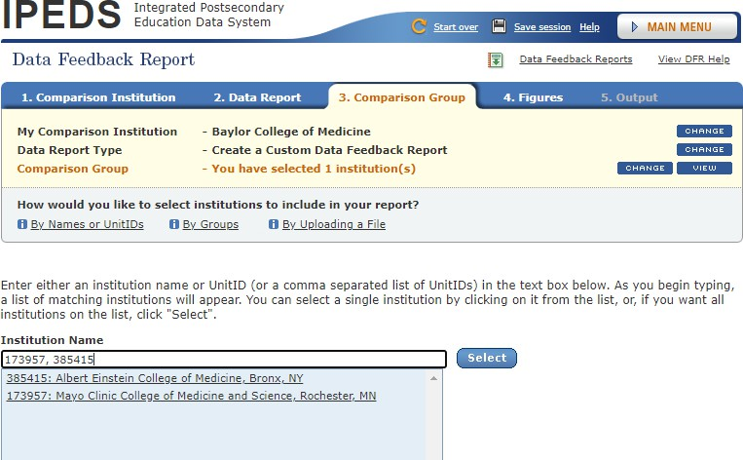
❻

Step 7: Select ins�tu�ons to include in the comparison by checking the
❽
boxes, and click the Con�nue boton.
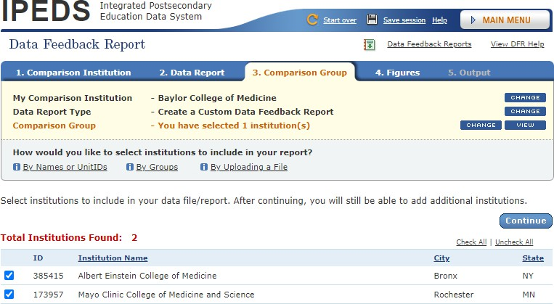
❼
Step 8: Click the CONTINUE boton when you conﬁrmed the list.
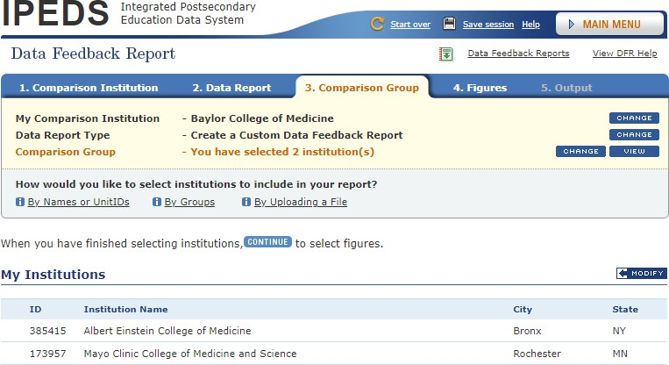

Step 9: Choose the ﬁgures of your interests by checking the boxes in front of each item regarding Student Enrollment, Awards, Military Beneﬁts, Finance, Staﬀ, and Libraries, and then click on the Con�nue buton.
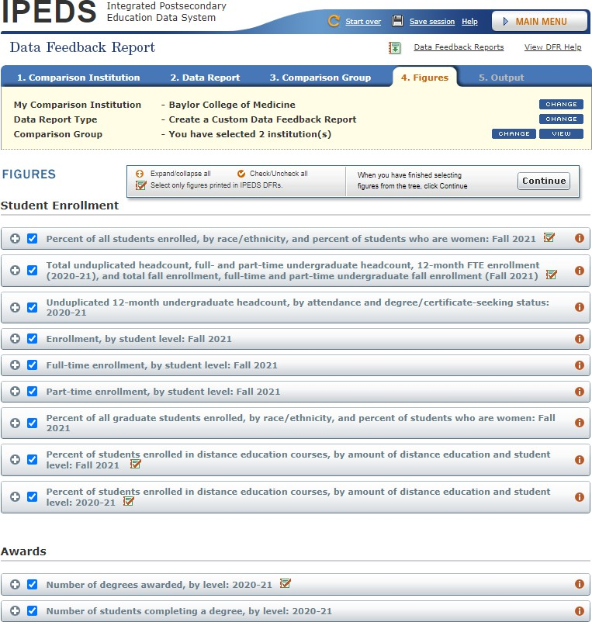
❾

Step 10: Download the Customized IPEDS Data Feedback Report by clicking the Download buton.

❿
Enjoy reading your report!

Scenario 2 – If you don’t have a speciﬁc ins�tu�on in mind for comparison
Step 6: Hover your mouse over By Groups, and click on the EZ Group.

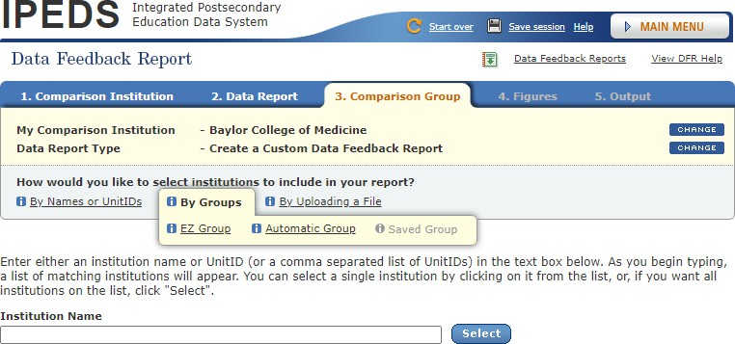
❻

Step 7: Select criteria by Select, Special missions, and Special characteris�cs to include ins�tu�ons by checking the boxes, and click onto the Search buton a�erward.

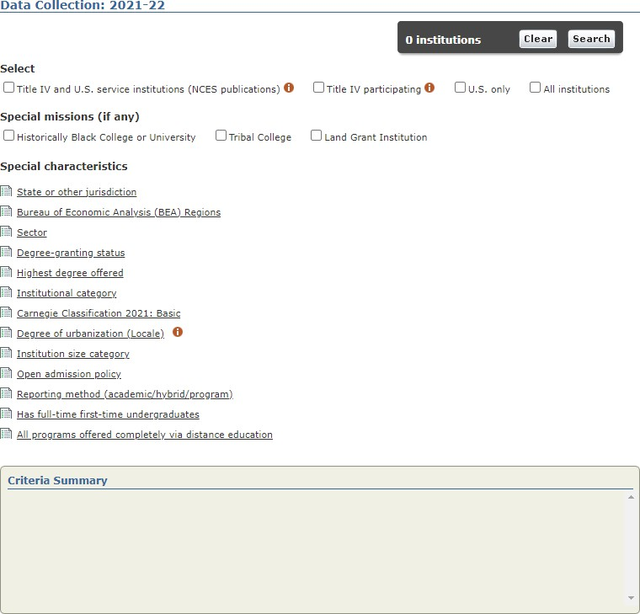
❼

Here is an example of selec�ng ins�tu�ons by two criteria:
- Sector: Private non-for-proﬁt, 4-year or above.
- Carnegie Classiﬁca�on 2021: Special Focus Four-year: Research Ins�tu�ons
and Special Focus Four-year: Medical Schools and Centers.
Please be aware that the number of ins�tu�ons may vary based on the speciﬁc criteria chosen. A Criteria Summary will be generated accordingly.
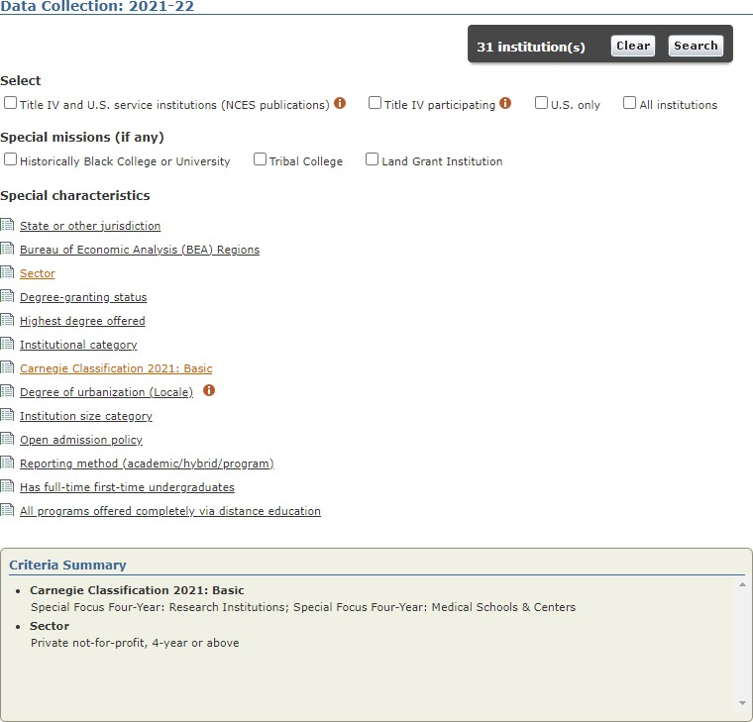

Step 8: Click the CONTINUE boton a�er you conﬁrmed the list.

❽
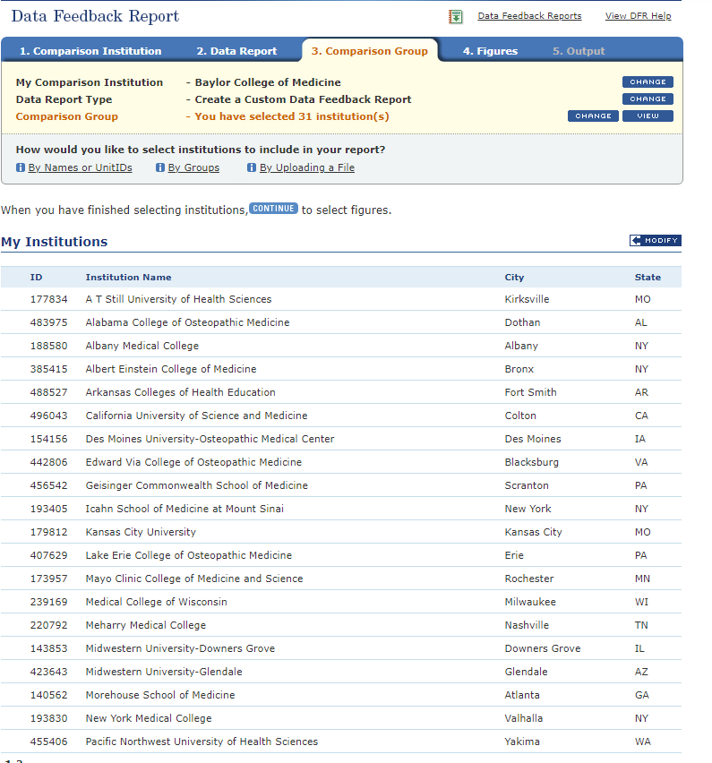

Step 9: Choose the ﬁgures of your interests by checking the boxes in front of each item regarding Student Enrollment, Awards, Military Beneﬁts, Finance, Staﬀ, and Libraries, and then click on the Con�nue buton.
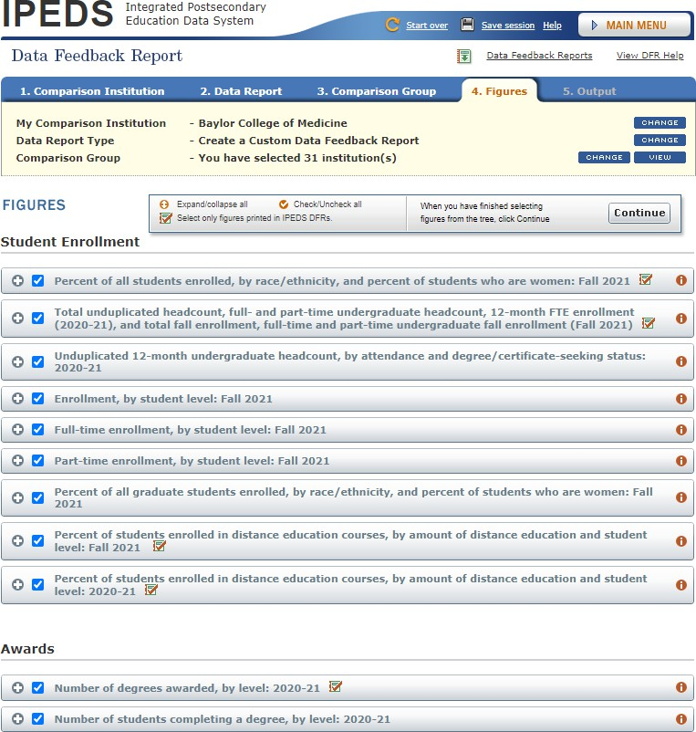
❾

Step 10: Download the Customized IPEDS Data Feedback Report by clicking the Download buton.

❿
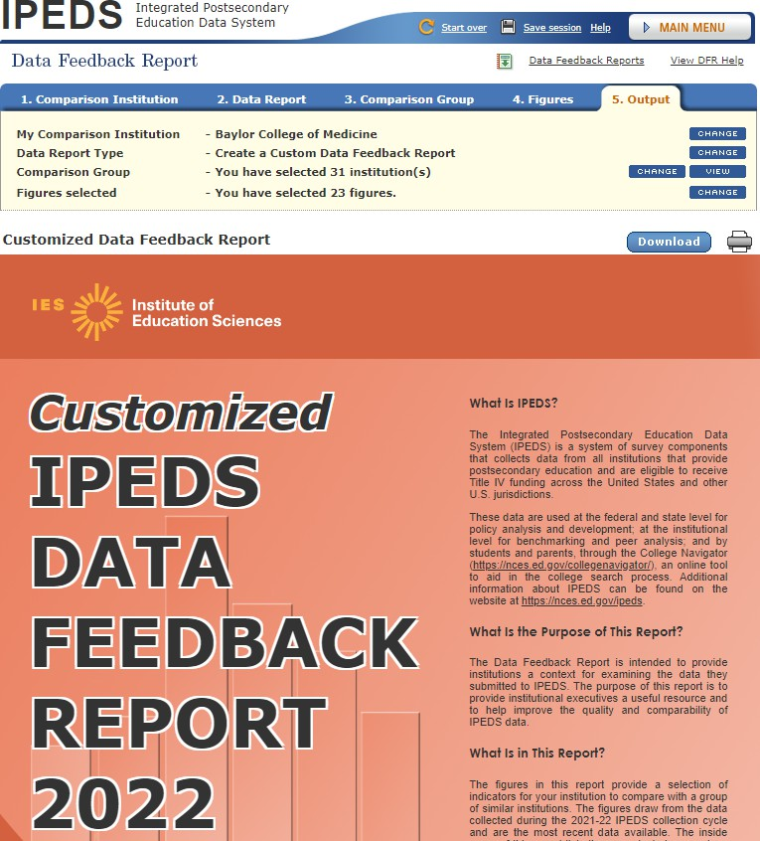
Enjoy reading your report!

Enjoy reading your report!

