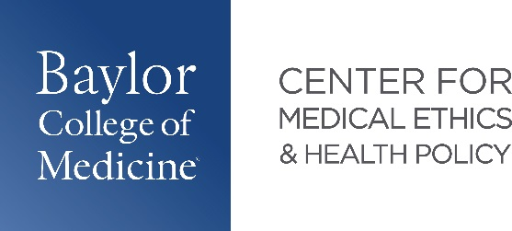

**2025 Health Policy Pathway Graduates**

|  |  |  |
| --- | --- | --- |
| Name | Project Title | Residency |
| Alexandra Alvarez | Financial Impact of Medical Credit Cards on Patients and Proposed Solutions:  A Narrative Review | **General Surgery**  Baylor College of Medicine  Houston, TX |
| Spoorthi Kamepalli | Early Changes in Liver Transplantation Outcomes Following Implementation of Acuity Circles | **Obstetrics & Gynecology**  Duke University  Durham, NC |
| Karena Kett | Association of limited English proficiency with length of stay in the Emergency Department | **Emergency Medicine**  UT Southwestern  Dallas, TX |
| Parker Mitchell* | Comparative Analysis of County-Based Healthcare Financial Assistance Programs: Characteristics and Utilization in the State of Texas -  *Does where you live determine the healthcare*  *you receive?* | **Orthopedic Surgery**  Tulane University  New Orleans, LA |
| William Porter | Healthcare Policy of Undocumented Immigrants: Recent Developments and Potential Impacts | **Internal Medicine - Pediatrics**  Baylor College of Medicine  Houston, TX |

*graduated SOM December 2024