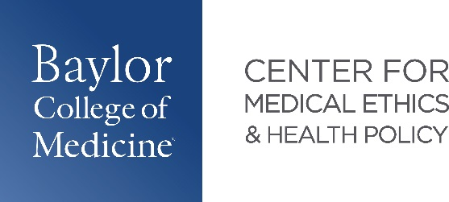

**2025 Medical Ethics Pathway Graduates**

|  |  |  |
| --- | --- | --- |
| Name | Project Title | Residency |
| Deborah Brisola | Uterus Transplantation and the Ethical Principle of Justice: Ensuring Equitable Access | **Obstetrics and Gynecology**  University of Texas Medical Branch  Galveston, TX |
| Jane Buell | Guidance for Difficult Circumstances in Denying A Tracheostomy | **Otolaryngology Head & Neck Surgery**  University of Colorado  Aurora, CO |
| Victoria Chen | Surrogate Rejection of Life-Saving Treatment for Non-Religious Reasons: A Case Study | **Psychiatry**  Yale School of Medicine  New Haven, CT |
| Jade Evenstad | I Believe You: An Ethical Approach to Disclosures of Sexual Victimization and Psychotic | **Family Medicine**  Geisinger Health (Geisinger South Wilkes-Barre)  Wilkes-Barre, PA |
| Shangyi (Shelly) Fu | Libertarian Paternalism and Biologics: Guiding Patient Decisions in Complex Therapeutics | **Dermatology**  Intern year: Baptist UAMS, North Little Rock AR  Residency: Texas Tech, Lubbock TX |
| Maya Guhan | Beyond Alignment: Navigating Ethical Tensions in Clinical AI Tool Development | **Internal Medicine**  UT Southwestern  Dallas, TX |
| Nathaniel Moss | The Seven C’s Framework: Promoting Equitable Access to Transplant Evaluation for Patients with Psychiatric Disorders | **Psychiatry**  University of Washington  Seattle, WA |
| Sierra Ehlers* | Nonabandonment as an Ethical Imperative:  Systemic Failures in Healthcare for Patients Experiencing Homelessness | **Surgical Breast Oncology Physician Assistant**  RWJ Barnabus Health  Livingston, NJ |
| Kara Hellweg* | Painfully Obvious: The Unspoken Truth  Behind IUD Consent | **Waiting for Update** |
| Annie Yang* | Defending the Integrity of Death with Dignity:  A Case for Upholding Current Legal Safeguards in Medical Aid in Dying | **Pediatric Hematology-Oncology**  Texas Children’s Hospital  Houston, TX |
|  |  |  |
| *graduated from the BCM School of Health Professions Physician Assistant program in December 2024 | | |