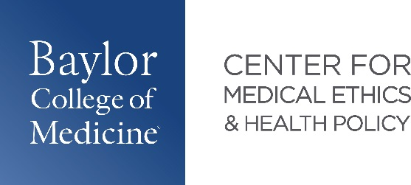

**2025 Graduates - Dual Medical Ethics and Health Policy Pathways**

|  |  |  |
| --- | --- | --- |
| Name | Project Title | Residency |
| Youssef Ahmed | Examining the utility of the Texas Child Psychiatry Access Network (CPAN) in reducing child and adolescent mental health crisis | **Psychiatry**  Baylor College of Medicine  Houston, TX |
| Mohammad Razvi | AI Use in Diagnostic Radiology from a Four Principles Approach | **Family Medicine**  University of Illinois at Chicago - Rockford  Rockford, IL |
| Rajadhar Reddy | Considerations for Medical Aid in Dying & Euthanasia in Patients with  Neurodegenerative Illness | **Internal Medicine**  Infirmary Health, Thomas Hospital  Fairhope, AL |
| McKenna Richards | Sex Education as Preventative  Reproductive Healthcare: The Potential Role  of Adolescent Consent | **Obstetrics & Gynecology**  University of Texas- Dell Medical School  Austin, TX |
| Kelvin Zhou | The Right to Notice and Explanation in Pediatric Radiology AI: Balancing Transparency and Trust | **Diagnostic Radiology**  UT Southwestern  Dallas, TX |